HDD for “Coaster”
- Block diagram of the coaster system
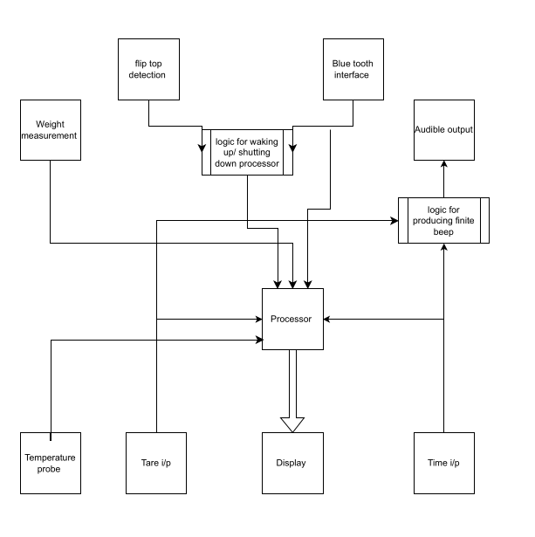
- Requirements
  - UI Inputs/Outputs :
    - System should have two touch pads for the timer start and tare feature
    - A flip top disc to start and shut down the system
    - A dsiplay capable of conveying all details with required numeric precision as mandated by timing and weight measurement requirements
  - Weight measurement
    - Coaster shall be capable of weighing in the full scale range of 3000 grams
    - Coaster shall be capable of weighing incremental changes of the order of 0.1 grams
    - coaster shall have an acceptable error of 2% FS range.
  - Temperature measurement requirements :
    - The addon thermal probe in coaster shall be capable of measuring in a FS range of 0-110 deg C
    - The thermal probe shall record data with minimum precision of 0.1deg C
    - The tolerable error for the thermal probe shall be 1%
  - Audio requirements

- Design details

- Source control

